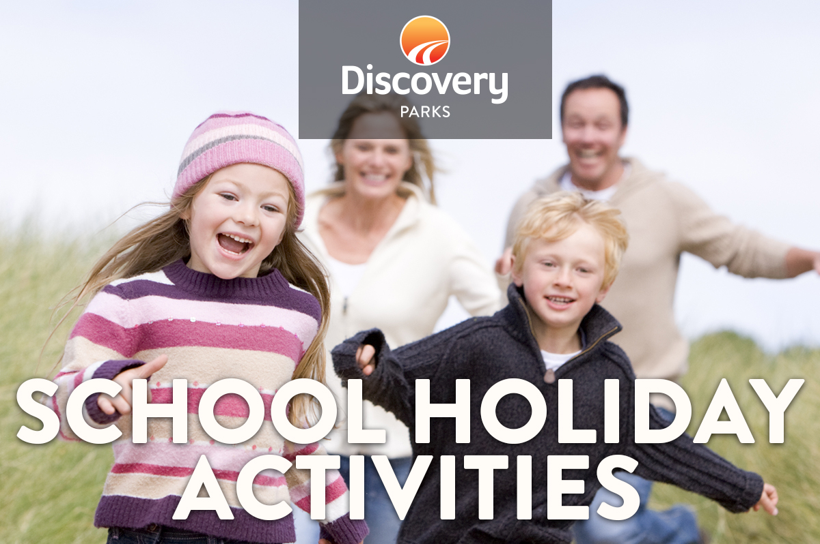
2019 WINTER SCHOOL HOLIDAYS
AT DISCOVERY PARKS – Adelaide Beachfront
Lots and lots of great holiday fun for all the family. From face painting and crazy crafts to movie nights, there’s activities planned throughout the school holidays.

DATE | TIME | ACTIVITY | VENUE | COST
Mon 8th  -  Sat 19th July |  | Kids Pack  (Assorted colouring competitions, activity sheet and more) | Reception  Every child gets one on arrival
Sat 13th July | 4pm | Pizza Truck | Next to the pool
Sun 14th July | 8am | Breaky Pizza | Next to the pool
Wed 10th July | 11am | Marble painting | Camp Kitchen | $1
Mon 15th July | 12pm | Cooking | Camp Kitchen | $2
Wed 17th July | 11am | Arts and Crafts | Camp Kitchen | $2
Fri 19th July | 11am | Slime making | Camp Kitchen | $2
 |  | *Dates of activities could be subject to change*

