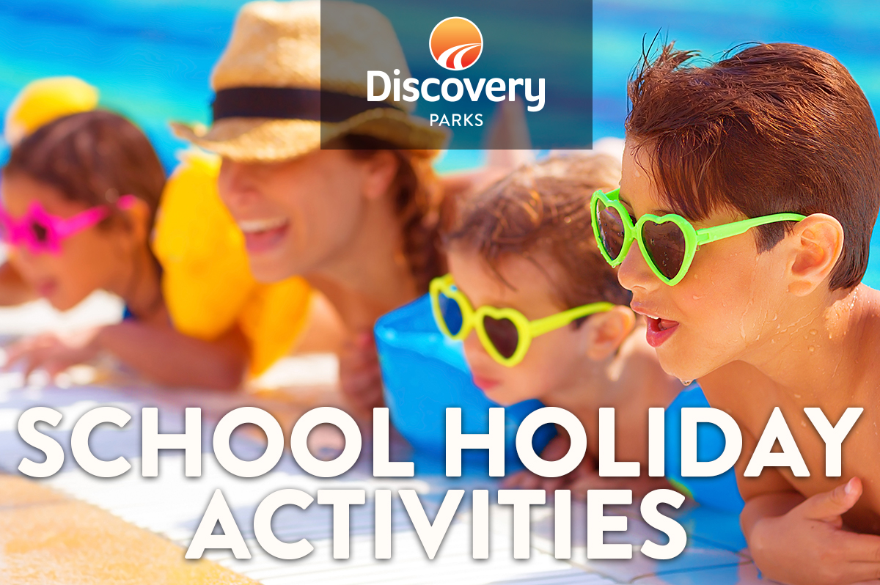
2019 JULY SCHOOL HOLIDAYS
AT DISCOVERY PARKS – Fraser Street
Lots and lots of great holiday fun for all the family. From face painting and crazy crafts to movie nights, there’s activities planned throughout the school holidays.

DATE | TIME | ACTIVITY | VENUE | COST
Sun 30th June | 5pm | Big Screen Movie | Games Room | Free
Mon 1st July |  | Grab an Activity Pack from Reception  Big Screen Movie | Reception  Games Room | Free
Tues 2nd July | 1.30pm | Jumping Pillow Games  Big Screen Movie | Jumping Pillow  Games Room | Free
Wed 3rd July | 1.30pm | Rock Painting  Big Screen Movie | Flippers Club  Games Room | Free
Thurs 4th July | 8.30am | Pancake Breakfast  Big Screen Movie | Camp Kitchen  Games Room | Gold Coin to Variety
Fri 5th July | 11.30am | Kids Can Cook - Banana Sushi  Big Screen Movie | Flippers Club | Free
Sat 6th July |  | Grab an Activity Pack from Reception  Big Screen Movie
Sun 7th July |  | Grab an Activity Pack from Reception  Big Screen Movie
Mon 8th July | 1.30pm | Whale Craft  Big Screen Movie | Flippers Club | Free
Tues 9th July | 1.30pm | Jumping Pillow Games  Big Screen Movie | Jumping Pillow | Free
Wed 10th July | 1.30pm | Rock Pool Craft  Big Screen Movie | Flippers Club | Free
Thurs 11th July | 8.30am | Pancake Breakfast  Big Screen Movie | Camp Kitchen | Gold Coin to Variety
Fri 12th July | 11.30am | Kids Can Cook – Apple Donuts  Big Screen Movie | Games Room | Free
Sat 13th July |  | Grab an Activity Pack from Reception  Big Screen Movie
Sun 14th July |  | Grab an Activity Pack from Reception  Big Screen Movie

