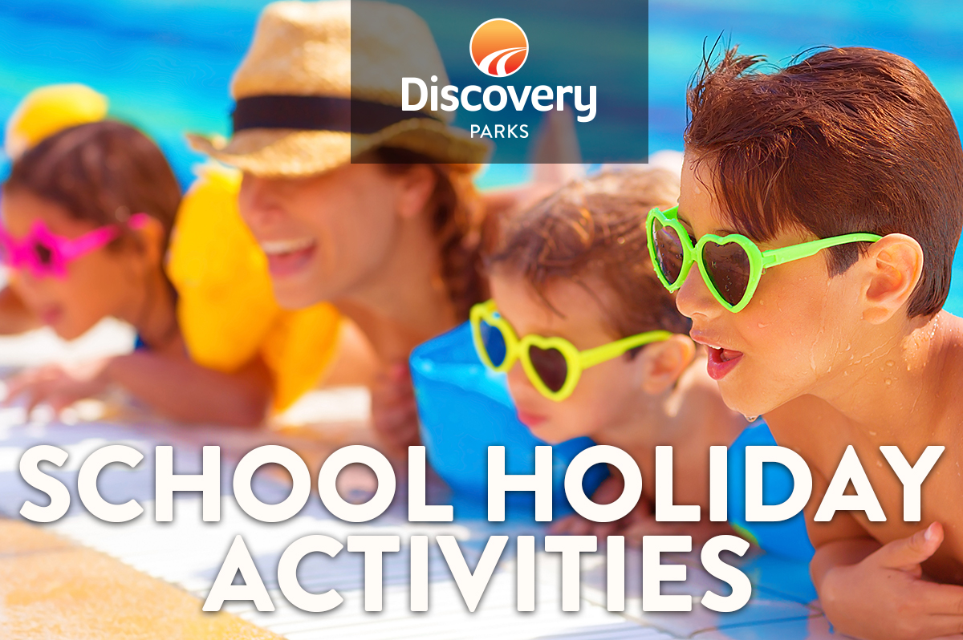
2019 EASTER SCHOOL HOLIDAYS
AT DISCOVERY PARKS –STREAKY BAY FORESHORE
Lots and lots of great holiday fun for all the family. From face painting and crazy crafts to movie nights, there’s activities planned throughout the school holidays.

DATE | TIME | ACTIVITY | VENUE | COST
13/04/19 |  | Guess how many eggs – Drawn Easter Monday | Reception | FREE
14/04/19 | 10am-2pm | Streaky Bay Markets | Streaky Bay Community Complex | FREE
15/04/19 | 10am – 4pm | FREE 1/2hr Berg Bike hire | Reception | FREE
16/04/19 | 8.30am – 5.30pm | FREE equipment hire | Reception | FREE
17/04/19 | 8.30am | Pancake Breakfast | West BBQ | Gold Coin Donation
20/04/19 | 10.30am | Find The Bunny Ears Competition | Start at Reception | FREE
21/04/19 | 8.30am | Hot Cross Bun Brekky | East BBQ | Gold Coin Donation
22/04/19 | 9.30am | Winner announced-How Many Eggs | Reception
23/04/19 | 8.30am-5.30pm | FREE 1/2hr Berg Bike Hire | Reception | FREE
24/04/19 | 8.30am | Pancake Brekky | West BBQ | Gold Coin Dontion
25/04/19 |  | ANZAC DAY – Dawn Service | Streaky Bay Jetty | FREE
26/04/19 | 10am - 4pm | FREE 1/2hr Berg Bike Hire | Reception | FREE
27/04/19 | 8.30am – 8.30pm | FREE equipment hire | Reception | FREE

