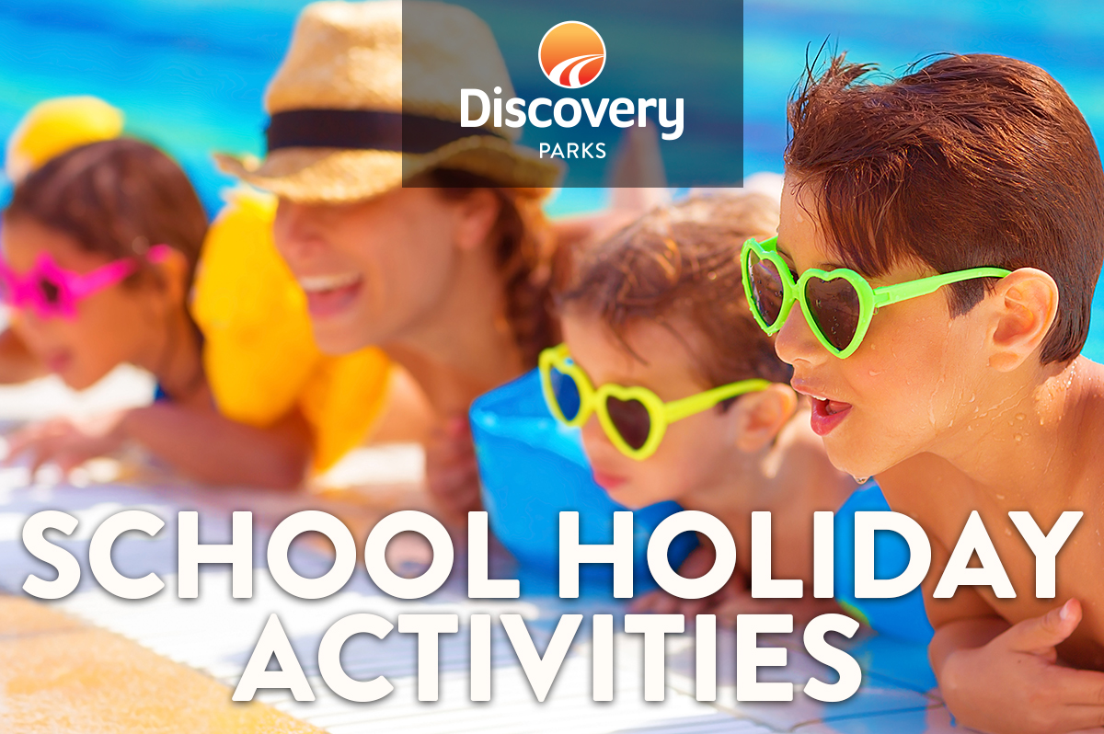
2019 AUTUMN SCHOOL HOLIDAYS
AT DISCOVERY PARKS – Airlie Beach

DATE | TIME | ACTIVITY | VENUE | COST
DAILY | 4PM | EASTER COLOURING COMPETITIONS DAILY | RECEPTION | FREE
SUN 07/04/2019 | 8AM | PANCAKE BREKKIE & BIRD FEEDING | POOL AREA | Gold Coin
MON 08/04/2019 | 12PM | MAKE YOUR OWN PIZZA | JUMPING PILLOW KITCHEN | $5EA
WED 10/04/2019 | 10AM | DECORARE YOUR OWN BISCUITS | JUMPING PILLOW KITCHEN | $2EA
FRI 12/04/2019 | 12PM | MAKE YOUR OWN SAUSAGE ROLL | JUMPING PILLOW KITCHEN | $5EA
SUN 14/04/2019 | 8AM | PANCAKE BREKKIE & BIRD FEEDING | POOL AREA | Gold Coin
MON 15/04/2019 | 12PM | MAKE YOUR OWN SAUSAGE ROLL | JUMPING PILLOW KITCHEN | $5EA
WED 17/04/2019 | 10AM | DECORARE YOUR OWN BISCUITS | JUMPING PILLOW KITCHEN | $2EA
FRI 19/04/2019 | 12PM | MAKE YOUR OWN PIZZA | JUMPING PILLOW KITCHEN | $5EA
SUN 21/04/2019 | 750AM | SUPER MASSIVE EASTER EGG HUNT | POOL AREA | FREE

