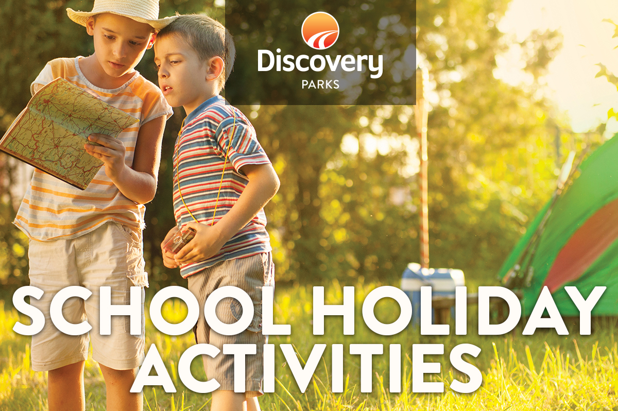
2019 AUTUMN SCHOOL HOLIDAYS
AT DISCOVERY PARKS – HERVEY BAY, FRASER STREET
Lots and lots of great holiday fun for all the family. From face painting and crazy crafts to movie nights, there’s activities planned throughout the school holidays.
DATE | TIME | ACTIVITY | VENUE | COST
Monday 08/04/19 | 4.00pm | Circus Workshop | Tennis Court
Tuesday 09/04/19 | 10.30am | Jumping Cushion Games | Jumping Cushion
Wednesday 10/04/19 | 10.30am | Easter Craft- Sock Bunny | Flippers Club
Thursday 11/04/19 | 8.30am  4.00pm | Pancake Breakfast  Drum Workshop | Flippers Club  Lakeside | Gold Coin
Friday 12/04/19 | 7.00pm | Movie Night | Tennis Court
Monday 15/04/19 | 10.30am | Wildlife Presentation | Games Room
Tuesday 16/04/19 | 10.30am | Jumping Cushion Games | Jumping Cushion
Wednesday 17/04/19 | 10.30am  5.30pm | Easter Craft- Hat Making  Easter Hat Parade and Dinner | Flippers Club  Tennis Court
Thursday 18/04/19 | 8.30am  4.00pm | Pancake Breakfast  Tie Dye | Flippers Club  Lakeside | Gold Coin  $12
Friday 19/04/19 | 6.00pm | Disco and Dinner | Flippers Club | $5
Sunday 21/04/19 | 9.00am | Easter Egg Hunt | Flippers Club

