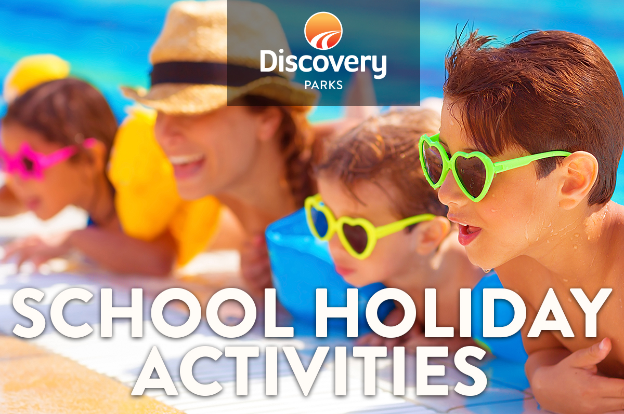
2018/19 SUMMER SCHOOL HOLIDAYS
AT DISCOVERY PARKS – ECHUCA
Lots and lots of great holiday fun for all the family. From face painting and crazy crafts to movie nights, there’s activities planned throughout the school holidays.

DATE | TIME | ACTIVITY | VENUE | COST
Wed 26th | DUSK | MOVIE NIGHT | LAWN AREA BEHIND OFFICE | Free
Thurs 27th | 5pm | MOKOS - music | CAMPING AREA | Free
Fri 28th | 10am | PONY RIDES | OUT THE FRONT OF THE DELUXE SPA CABINS | Free
Sat 29th | DUSK | MOVIE NIGHT | LAWN AREA BEHIND OFFICE | Free
Sun 30th | 9am | BREAKFAST – CARMA ANIMAL RESCUE | BBQ AREA | Gold Coin Donation
Mon 31st | 6.30pm | NEW YEARS EVE DISCO | LAWN AREA BEHND OFFICE | Free
Wed 2nd | 5.30 pm | SEAFOOD FOOD TRUCK | BBQ AREA
Wed 2nd | DUSK | MOVIE NIGHT | LAWN AREA BEHIND OFFICE | Free
Thurs 3rd | 5.00pm | MOKOS – music | CAMPING AREA | Free
Thurs 3rd | 5.30 pm | SEAFOOD FOOD TRUCK | BBQ AREA
Fri 4th | 10am | PONY RIDES | OUT THE FRONT OF THE DELUXE SPA CABINS | Free
Sat 5th | DUSK | MOVIE NIGHT | LAWN AREA BEHIND OFFICE | Free
Sun 6th | 9am | BREAKFAST – CARMA ANIMAL RESCUE | BBQ AREA | Gold coin donation
Wed 9th | DUSK | MOVIE NIGHT | LAWN AREA BEHIND OFFICE | Free
Fri 11th | 10am | PONY RIDES | OUT THE FRONT OF THE DELUXE SPA CABINS | Free
Sat 12th | DUSK | MOVIE NIGHT | LAWN AREA BEHIND OFFICE | Free
Sun 13th | 9am | BREAKFAST – CARMA ANIMAL RESCUE | BBQ AREA | Gold coin donation
 |  | AUSTRALIA DAY WEEKEND
Fri 25th Jan | 6pm | HOT DOG DINNER | BBQ AREA | Free
Sat 26th Jan |  | CHAINSAW CARVING EXPERT | BBQ AREA | Free
 |  | WOOL WAGON RIDES | OUT THE FRONT OF THE DELUXE SPA CABINS | Free
Sun 27th Jan | 9.00am | BREAKFAST – CARMA ANIMAL RESCUE | BBQ AREA
Sun 27th Jan | 5.30pm | KEIRAN KEATS – COUNTRY MUSIC | CAMPING AREA | Free

- Coffee van will be in the park every day from the 26th of December until the 13th of January – open at 8am till 11am.
- Colouring Competition every day great prize’s
- Count the lollies in the Jar

