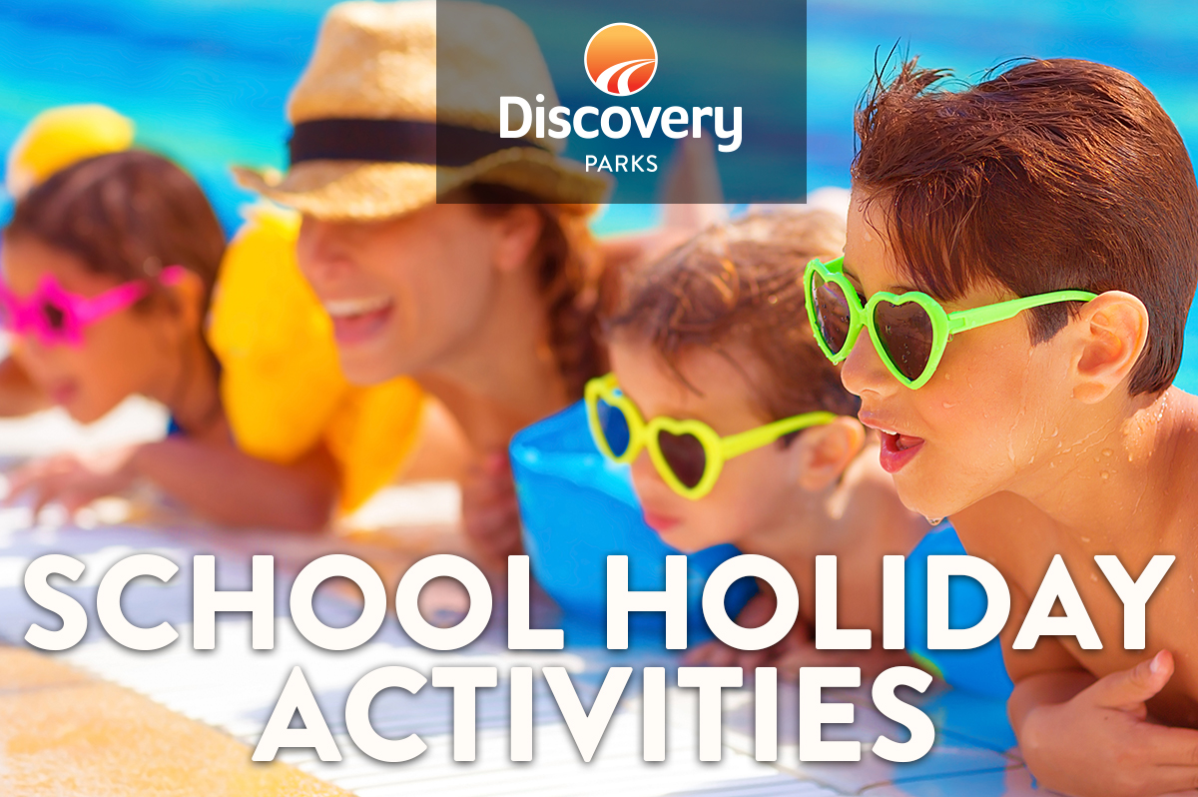
2018/19 SUMMER SCHOOL HOLIDAYS
AT DISCOVERY PARKS – MAIDENS INN, MOAMA
Lots and lots of great holiday fun for all the family. From face painting and crazy crafts to movie nights, there’s activities planned throughout the school holidays.

DATE | TIME | ACTIVITY | VENUE | COST
27/12/2018 | All Day | Colouring Competition (Drawn 1st January) | Collect from Reception | Free
27/12/2018 | All Day | Count the lollies in the jar (Drawn 1st January) | Reception | Free
27/12/2018 | 7:00pm | Outdoor Movie (A Wrinkle In Time) | On the Point | Free
28/12/2018 | 11:00am – 12:00pm | Leighs Reptiles | Around the Lake | Free
28/12/2018 | 4:00pm – 7:00pm | Live Music (Caravan sessions) | TBA | Free
29/12/2018 | 10:00am – 11:00pm | Toddler Time (Allowing younger and smaller kids to have time on the jumping pillow) | Jumping Pillow | Free
29/12/2018 | 2:00pm | Outdoor Movie (Coco) | On the Point | Free
30/12/2018 | 2:00pm | Outdoor Movie (Sherlock Gnomes) | On the Point | Free
31/01/2019 & 01/01/2019 | 6:00pm – 10:00pm | Elephant Rock Street Food | Near Reception | As per Menu
02/01/2019 | All Day | Colouring competition (Drawn 8th January) | Collect from Reception | Free
02/01/2019 | 10:00am – 11:00am | Toddler Time (Allowing younger and smaller kids to have time on the jumping pillow) | Jumping Pillow | Free
02/01/2019 | All Day | Count the lollies in the jar (Drawn 8th January) | Reception | Free
02/01/2019 | 4:00pm – 7:00pm | Live Music (Caravan Sessions) | TBA | Free
03/01/2019 – 18/01/2019 | All Day | Soul M8s Food Truck | Near Reception | As Per Menu
03/01/2019 | 11:00am – 12:00pm | Leighs Reptiles | Around the Lake | Free
03/01/2019 | 7:00pm | Outdoor Movie (The Greatest Showman) | On the Point | Free
05/01/2019 | 10:00am – 11:00am | Toddler Time (Allowing younger and smaller kids to have time on the jumping pillow) | Jumping Pillow | Free
05/01/2019 | 2:00pm | Outdoor Movie (A Wrinkle In Time) | On the Point | Free
07/01/2019 | 11:00am – 12:00pm | Twisted Science (Wacky Worms) | Cottonwood Camp Kitchen | Free
08/01/2019 | 11:00am – 1:00pm | Billabong Ranch (Camel Rides) | Around the Lake | Free
09/01/2019 | 10:00am – 11:00am | Toddler Time (Allowing younger and smaller kids to have time on the jumping pillow) | Jumping Pillow | Free
11/01/2019 | 7:00pm | Outdoor Movie (Coco) | On the Point | Free
12/01/2019 | 2:00pm | Outdoor Movie (Sherlock Gnomes) | On the Point | Free
14/01/2019 | 11:00am – 12:00pm | Twisted science (Bubble Mania) | Cottonwood Camp Kitchen | Free
16/01/2019 | 1:00pm – 3:00pm | Face Painting | Maidens Camp kitchen | Free
18/01/2019 | 7:00pm | Outdoor Movie (The Greatest Showman) | On the Point | Free
19/01/2019 | 4:00pm – 6:00pm | Live Music (The Ramage Boys) | TBA | Free
25/01/2019 | All Day | Australia Day Colouring competition (Drawn 27th January) | Collect from Reception | Free

