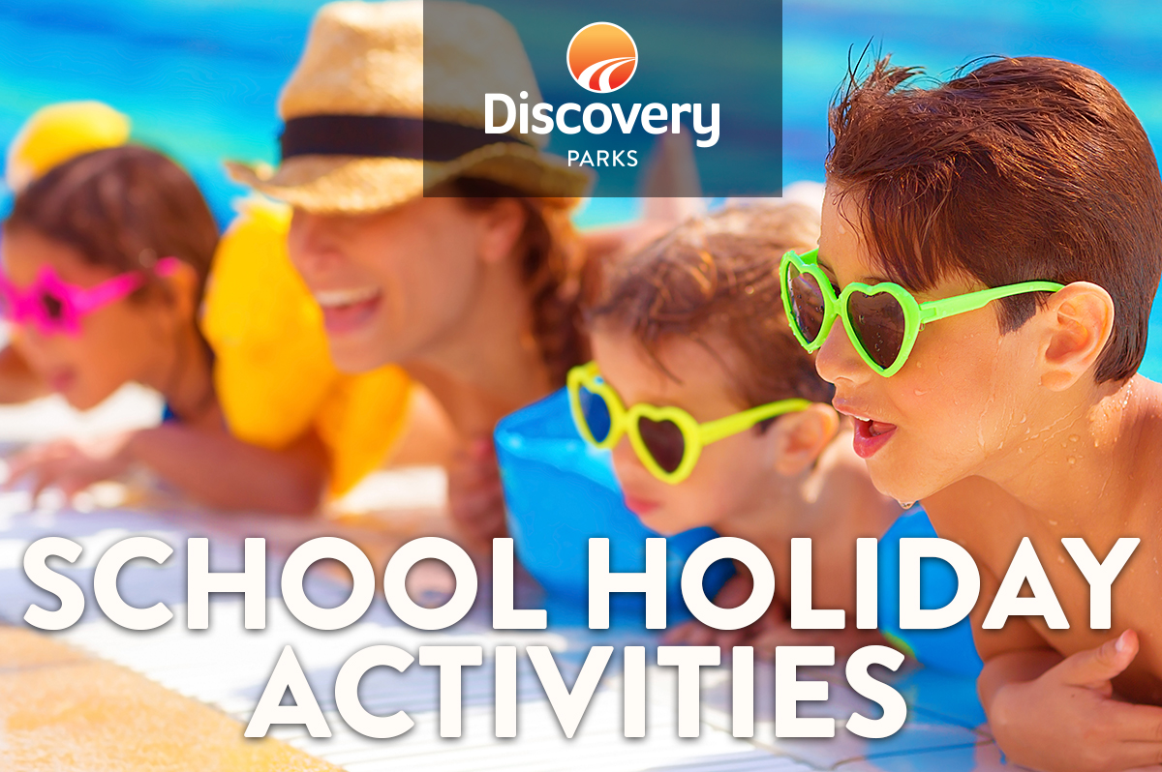
2018/19 SUMMER SCHOOL HOLIDAYS
AT DISCOVERY PARKS – ROCKHAMPTON
Lots and lots of great holiday fun for all the family. From face painting and crazy crafts to movie nights, there’s activities planned throughout the school holidays.

DATE | TIME | ACTIVITY | VENUE | COST
 |  | COLOURING COMPETITION (WEEKLY) | RECEPTION | FREE
17TH DEC | 8AM | PANCAKE BREAKFAST | CAMP KITCHEN | GOLD COIN DONATION
18TH DEC | 10AM | FACE PAINTING | CAMP KITCHEN | FREE
20TH DEC | 6PM | SAUSAGE SIZZLE | CAMP KITCHEN | GOLD COIN DONATION
21ST DEC | 6PM | MOVIE NIGHT | RECREATION ROOM | FREE
23RD DEC | 10AM | ARTS AND CRAFTS | RECREATION ROOM | FREE
24TH DEC | 8AM | PANCAKE BREAKFAST | CAMP KITCHEN | GOLD COIN DONATION
27TH DEC | 6PM | SAUSAGE SIZZLE | CAMP KITCHEN | GOLD COIN DONATION
28TH DEC | 6PM | MOVIE NIGHT | RECREATION ROOM | FREE
30TH DEC | 10AM | ARTS AND CRAFTS | RECREATION ROOM | FREE
31ST DEC | 6PM | DISCO | RECREATION ROOM
3RD JAN | 6PM | SAUSAGE SIZZLE | CAMP KITCHEN | GOLD COIN DONATION
6TH JAN | 10AM | ARTS AND CRAFTS | RECREATION ROOM | FREE
7TH JAN | 8AM | PANCAKE BREAKFAST | CAMP KITCHEN | GOLD COIN DONATION
8TH JAN | 10AM | FACE PAINTING | CAMP KITCHEN | FREE
10TH JAN | 6PM | SAUSAGE SIZZLE | CAMP KITCHEN | GOLD COIN DONATION
11TH JAN | 6PM | DISCO | RECREATION ROOM | FREE
13TH JAN | 10AM | ARTS AND CRAFTS | RECREATION ROOM | FREE
14TH JAN | 8AM | PANCAKE BREAKFAST | CAMP KITCHEN | GOLD COIN DONATION
15TH JAN | 10AM | FACE PAINTING | CAMP KITCHEN | FREE
17TH JAN | 6PM | SAUSAGE SIZZLE | CAMP KITCHEN | GOLD COIN DONATION
20TH JAN | 6PM | MOVIE NIGHT | RECREATION ROOM | FREE
21ST JAN | 10AM | ARTS AND CRAFTS | RECREATION ROOM | FREE
24TH JAN | 6PM | SAUSAGE SIZZLE | CAMP KITCHEN | GOLD COIN DONATION
25TH JAN | 6PM | MOVIE NIGHT | RECREATION ROOM | FREE
26TH JAN | 6PM | SAUSAGE SIZZLE | CAMP KITCHEN | GOLD COIN DONATION

