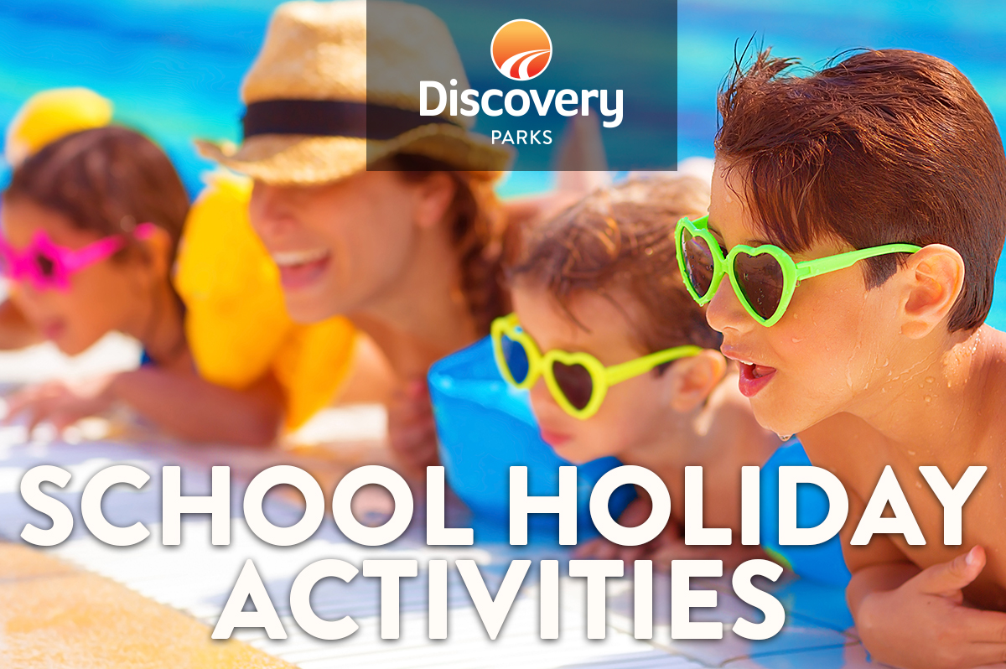
2018/19 SUMMER SCHOOL HOLIDAYS
AT DISCOVERY PARKS – Airlie Beach

DATE | TIME | ACTIVITY | VENUE | COST
 |  | COLOURING COMPETITIONS DAILY | RECEPTION | FREE
19/12/2018 | 630PM | MOVIE NIGHT | Jumping Pillow | FREE  Snacks on Sale
23/12/2018 | 8AM | Pancake Brekkie by the pool | Pool Area  After Bird Feeding | Gold Coin  Donation
23/12/2018 | 630PM | MOVIE NIGHT | Pool Area  After Bird Feeding | Gold Coin  Donation
24/12/2018 | 10AM | Christmas arts and crafts  “Make your own Rudolph” | Bottom Camp Kitchen | $5 Per Child  (2 Ornaments)
28/12/2018 | 630PM | MOVIE NIGHT | Jumping Pillow | FREE  Snacks on Sale
29/12/2018 | 12PM | Make your own PIZZA | Bottom Camp Kitchen | $5ea
30/12/2018 | 8AM | Pancake Brekkie by the pool | Pool Area  After Bird Feeding | Gold Coin  Donation
03/01/2019 | 10AM | Face Painting and games | BBQ Area  Behind Jumping Pillow | Free
05/01/2019 | 630PM | MOVIE NIGHT | Jumping Pillow | FREE  Snacks on Sale
06/01/2019 | 8AM | Pancake Brekkie by the pool | Pool Area  After Bird Feeding | Gold Coin  Donation
07/01/2019 | 630PM | MOVIE NIGHT | Jumping Pillow | FREE  Snacks on Sale
09/01/2019 | 12PM | Make your own Sausage Rolls | Bottom Camp Kitchen | $5ea
11/01/2019 | 630PM | MOVIE NIGHT | Jumping Pillow | FREE  Snacks on Sale
12/01/2019 | 8AM | Pancake Brekkie by the pool | Pool Area  After Bird Feeding | Gold Coin  Donation

