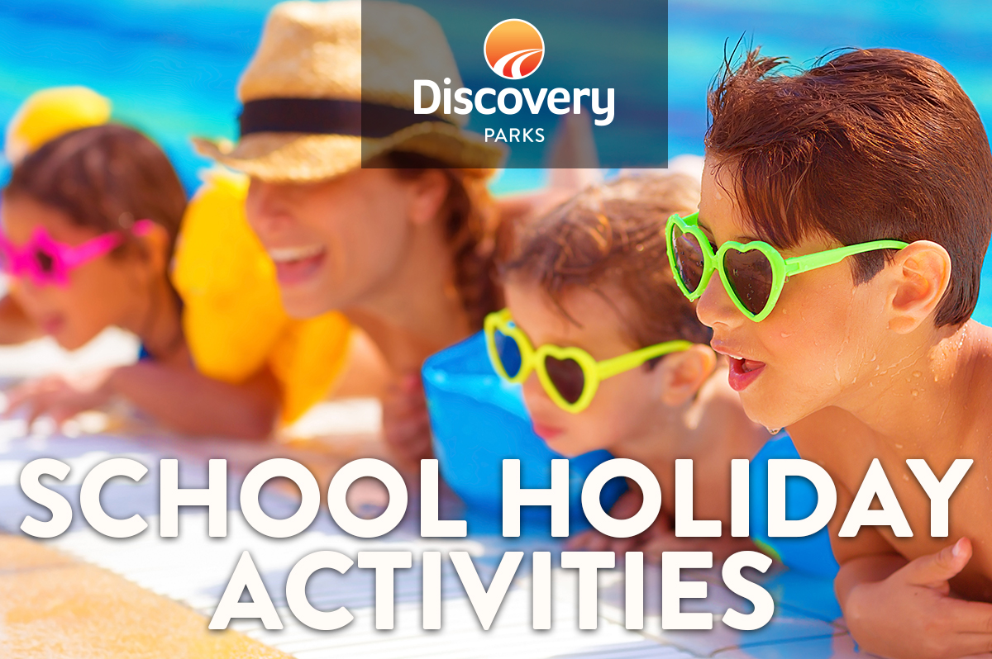
2018/19 SUMMER SCHOOL HOLIDAYS
AT DISCOVERY PARKS – Lake Bonney
Lots and lots of great holiday fun for all the family. From face painting and crazy crafts to movie nights, there’s activities planned throughout the school holidays.

DATE |  | TIME | ACTIVITY | VENUE | COST
15th Dec  15th Dec  17th Dec  19th Dec  20th Dec  23rd Dec |  | 4pm  7.30pm  10am-3.30  4pm  7.30pm  TBA | Santa’s Beach Cave-meet beach Santa with girls and boys lucky dips  Movie night  Where’s Harry  Santa’s Beach Cave-meet beach Santa with girls and boys luck dips  Movie night  Petting Farm – Pony rides | Front beach  Lake shed  Reception  Front Beach  Lake Shed  Lake Shed | free  free  free  free  free  free
27th Dec |  | 6pm | El Gringo Mexican Food van | Lake Shed | free
27th Dec |  | 8pm | Movie | Lake Shed | Free
28th Dec |  | All Day | Puzzle Day | See reception | Free
28th Dec |  | TBA | Mishes Kitchen Vietnamese food | Waterpark | TBA
29th Dec |  | 7am-11am | Little Miss Daisy Coffee van | Waterpark | TBA
29th Dec |  | TBA | Mishes Kitchen Vietnamese food | Waterpark | tba
29TH Dec |  | 8pm | Movie | Lake Shed | Tba
31st Dec |  | 7am-11am | Little Miss Daisy Coffee van | Waterpark | TBA
31st Dec |  | 7:30pm | Best decorated bike parade | Waterpark | Free
31st Dec |  | 8pm | Movie | Lake shed | Free
1st Jan |  | 6pm | El Gringo Mexican Food van | Lake Shed
1st Jan |  | 8pm | Movie | Lake Shed | Free
2nd Jan |  | 7am-11am | Little Miss Daisy Coffee van | Waterpark | TBA
2nd Jan |  | All Day | Puzzle Day | See reception | Free
3rd Jan |  | 8pm | Movie | Lake Shed | Free
4th Jan |  | 7am-11am | Little Miss Daisy Coffee van | Waterpark | TBA
4th Jan |  | All Day | Puzzle Day | See reception | Free
5th Jan |  | TBA | Mishes Kitchen Vietnamese food | Waterpark | TBA
5th Jan |  | 8pm | Movie | Lake Shed | Tba
5th Jan |  | TBA | Talent quest | Lake Shed | Free
6th Jan |  | 7am-11am | Little Miss Daisy Coffee van | Waterpark | TBA
7th Jan |  | 10am | Where’s Harry | All park | Free
8th Jan |  | 7am-11am | Little Miss Daisy Coffee van | Waterpark | TBA
8th Jan |  | 6pm | El Gringo Mexican Food van | Lake Shed
8th Jan |  | 8pm | Movie | Lake Shed | Free
9th Jan |  | All Day | Puzzle Day | See reception | Free
10th Jan |  | 7am-11am | Little Miss Daisy Coffee van | Waterpark | TBA
10th Jan |  | 8pm | Movie | Lake Shed | Tba
10th Jan |  | 6pm | Pat’s Thai food van | TBA | TBA
 | 11th Jan | All Day | Puzzle Day | See reception | Free
12th Jan |  | 7am-11am | Little Miss Daisy Coffee van | Waterpark | TBA
12th Jan |  | TBA | Mishes Kitchen Vietnamese food | Waterpark | TBA
12th Jan |  | 8pm | Movie | Lake Shed | Tba
14th Jan |  | 7am-11am | Little Miss Daisy Coffee van | Waterpark | TBA
14th Jan |  | 10am | Where’s Harry | All park | Free
15th Jan |  | 7am-11am | Little Miss Daisy Coffee van | Waterpark | TBA
15th Jan |  | 6pm | El Gringo Mexican Food van | Lake Shed
15th JAn |  | 8pm | Movie | Lake Shed | Free
 | 16th Jan | All Day | Puzzle Day | See reception | Free
17th Jan |  | 8pm | Movie | Lake Shed | Tba
17th Jan |  | 6pm | Pat’s Thai food van | TBA | TBA
18th Jan |  | All Day | Puzzle Day | See reception | Free
19th Jan |  | TBA | Petting Farm – Pony rides | Lake shed
19th Jan |  | TBA | Mishes Kitchen Vietnamese food | Waterpark | TBA
19th Jan |  | 8pm | Movie | Lake Shed | Tba
20th Jan |  | TBA | Petting Farm – Pony rides | Lake shed
21st Jan |  | 10am | Where’s Harry | All park | Free
22nd Jan |  | 6pm | El Gringo Mexican Food van | Lake Shed
22nd Jan |  | 8pm | Movie | Lake Shed | Free
23rd Jan |  | All Day | Puzzle Day | See reception | Free
24th Jan |  | 8pm | Movie | Lake Shed | Tba
24th Jan |  | 6pm | Pat’s Thai food van | TBA | TBA
25th Jan |  | All Day | Puzzle Day | See reception | Free
26th Jan |  | 7am-11am | Little Miss Daisy Coffee van | Waterpark | TBA
26th Jan |  | 6pm | Australia Day Beach Twilight Disco | Front Beach | Free
27th Jan |  | 7am-11am | Little Miss Daisy Coffee van | Waterpark | TBA

