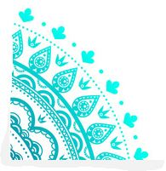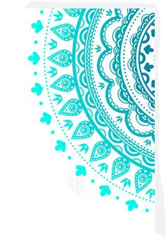

Classes are FREE and tailored for your level of practice – if you’ve never done yoga before, now’s your chance to try.

**Start your day with a peaceful yoga flow.**

If you have any questions please ask at reception or call Glenys on 0402842008

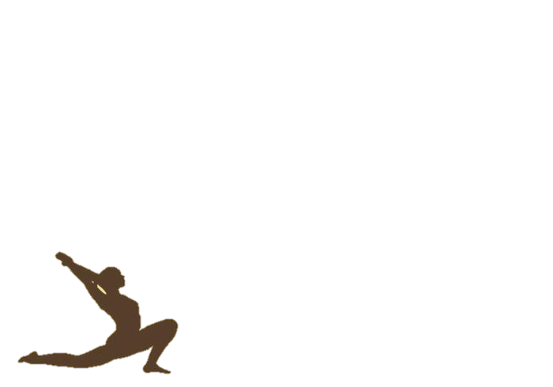

*Discovery Holiday Park Byron Bay presents*

**YOGA**

**FREE** yoga flow classes

with Glenys Campbell **7am-8am**

**Monday, Wednesday and Saturday**

Meet us at the Lakeside Pavilion

(just behind the jumping pillow and pool area)