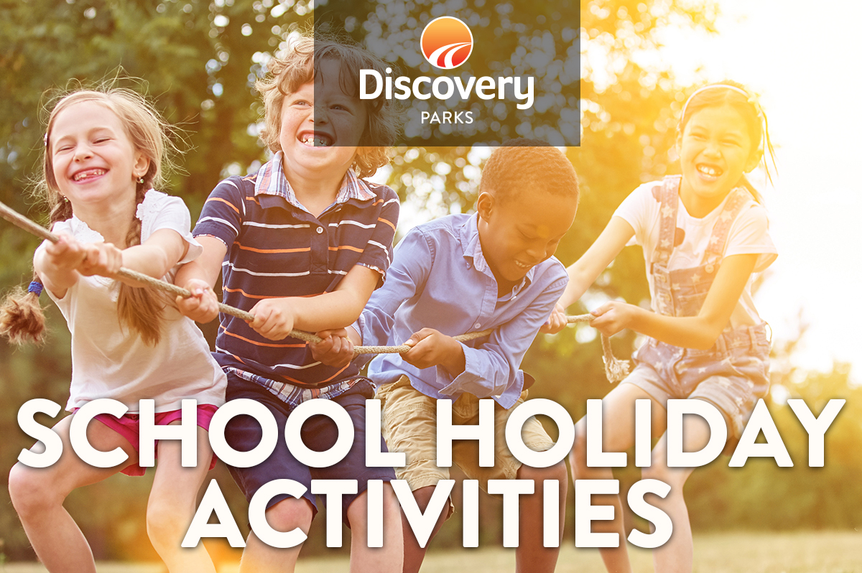
2018 SPRING SCHOOL HOLIDAYS
AT DISCOVERY PARKS – PILBARA
Lots and lots of great holiday fun for all the family. From face painting and crazy crafts to movie nights, there’s activities planned throughout the school holidays.

DATE | TIME | ACTIVITY | VENUE | COST
Sat 23rd | 1-3pm | Pedal cart obstacle course comp | Pool car park | GCD
Tues 25th | 2pm-5pm | Movie, popcorn and drink | Recreation Room | Free
Wed 26th | 6pm-8pm | Burger and sausage sizzle kids + bocce comp | Function Room | GCD
Fri 28th | 9am-11am | Swimming pool activities | Pool area | Free
Sat 29th | 2pm-5pm | Movie, Popcorn and drink | Recreation Room | Free
Sun 30th | 11am-2pm | Free Go Carts | Office | Free
Mon 1st | 11am-2pm | Free Go Carts | Office
Sun 2nd | 9am-12pm | Colouring in Comp | Rego @ Office | Free
Mon 3rd | 2pm=5pm | Movie, popcorn and drink | Function Room | Free
Tue 4th | 4pm-7pm | Disco and Games | Function Room | Free
Wed 5th | 6pm-8pm | Burger and sausage sizzle kids + bocce comp | Function Room | GCD
Thurs 6th | 10am-12pm | Swimming pool activities | Pool Area | Free
Fri 7th | 10am-2pm | Free Go Carts | Office | Free

