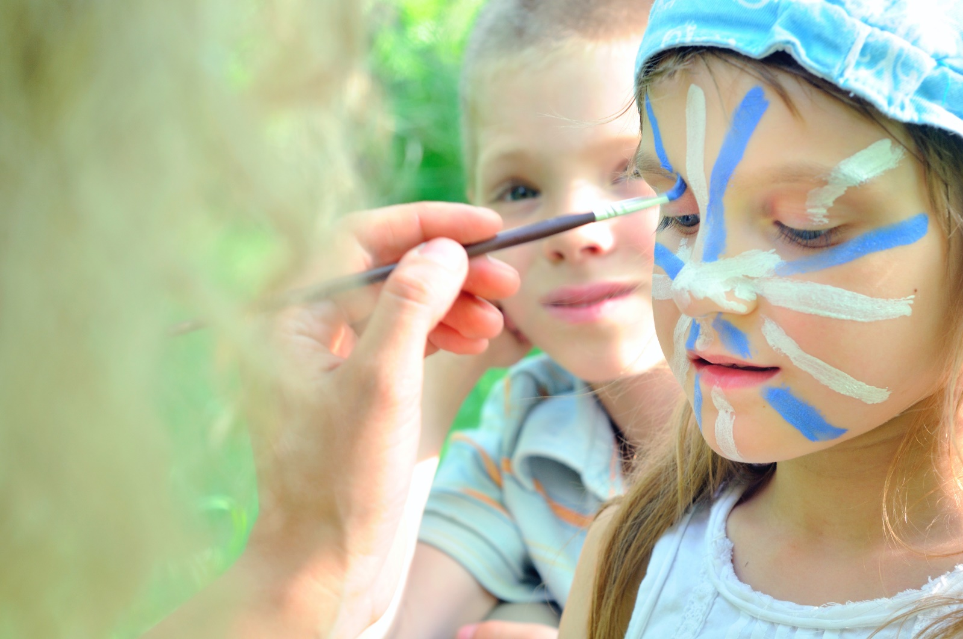
SCHOOL HOLIDAY
ACTIVITIES
School Holidays June – July 2018
AT DISCOVERY PARKS – FRASER STREET, HERVEY BAY

DATE | TIME | ACTIVITY | VENUE | COST
1/7/18 | 5.00pm | Movie | Flippers Club | Free
2/7/18 | 1.00pm  5.00pm | Mural Painting  Movie | Front Laundry  Flippers Club | Free  Free
3/7/18 | 10.30am  5.00pm | Jumping Pillow Games  Movie | Jumping Pillow  Flippers Club | Free  Free
4/7/18 | 1.00pm  5.00pm | Pom Pom Making  Movie | Flippers Club  Flippers Club | Free  Free
5/7/18 | 8.30am  10.00am  5.00pm | Pancake Breakfast  Mural Painting  Movie | Main Camp Kitchen  Front Laundry  Flippers Club | Gold Coin  Free  Free
6/7/18 | 1.00pm  5.00pm | Playdough Making  Movie | Flippers Club  Flippers Club | Free  Free
7/7/18 | 5.00pm | Movie | Flippers Club | Free
8/7/18 | 5.00pm | Movie | Flippers Club | Free
9/7/18 | 1.00pm  5.00pm | Balloon Bonanza  Movie | Flippers Club  Flippers Club | Free  Free
10/7/18 | 10.30am  5.00pm | Jumping Pillow Games  Movie | Jumping Pillow  Flippers Club | Free  Free
11/7/18 | 1.00pm  5.00pm | Bubble Painting  Movie | Flippers Club  Flippers Club | Free  Free
12/7/18 | 8.30am  10.00am  5.00pm | Pancake Breakfast  Mural Painting  Movie | Main Camp Kitchen  Front Laundry  Flippers Club | Gold Coin  Free  Free
13/7/18 | 1.00pm  5.00pm | Marble Run  Movie | Flippers Club  Flippers Club | Free  Free
14/7/18 | 5.00pm | Movie | Flippers Club | Free
15/7/18 | 5.00pm | Movie | Flippers Club | Free

