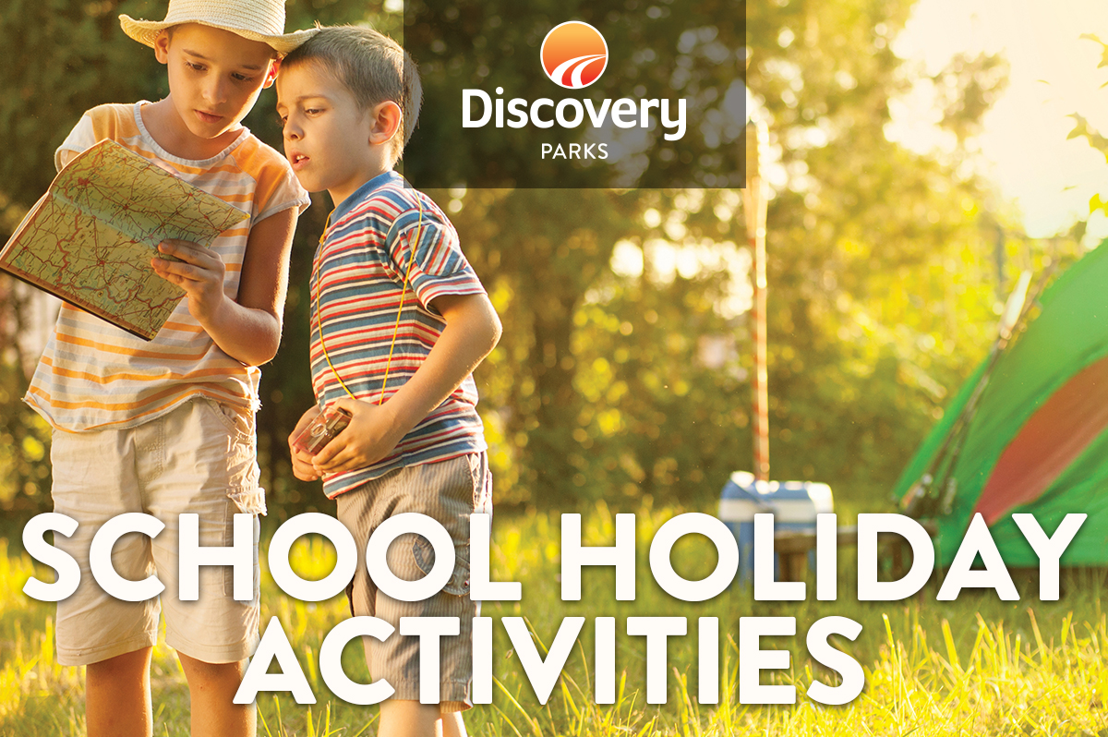
2018 AUTUMN SCHOOL HOLIDAYS
AT DISCOVERY PARKS – WOODMAN POINT
Lots and lots of great holiday fun for all the family. From face painting and crazy crafts to movie nights, there’s activities planned throughout the school holidays.

DATE | TIME | ACTIVITY | VENUE | COST
29/3 | All Day | The great race starts | Reception | Free
30/3 | 10am-12am | Face Painting | Front Lawn | Free
30/3 | 2pm – 3pm | Waterslide Action | Front Lawn | Free
30/3 | 7pm | Movie | Front Lawn | Free
31/3 | 10am -11am | Gym Bus | Near Jumping Pillow | Free
31/3 | 11am-12pm | Pitch a tent race | Front Lawn | Free
31/3 | 2pm – 3pm | Waterslide Action | Front Lawn | Free
01/4 | 10am-11am | Egg and Spoon Race | Front Lawn | Free
01/4 | 1pm-2pm | Visit from Easter Bunny | Golf Buggy | Free
01/4 | 2pm – 3pm | Waterslide Action | Front Lawn | Free
01/4 | 7pm | Movie | Front Lawn | Free
02/4 | 3pm-4pm | Kids Magic Show | Front Lawn | Free
02/4 | 4pm-5pm | The great race finishes- entrants papers returned to reception | Reception | Free
02/4 | 7pm | Movie | Front Lawn | Free

