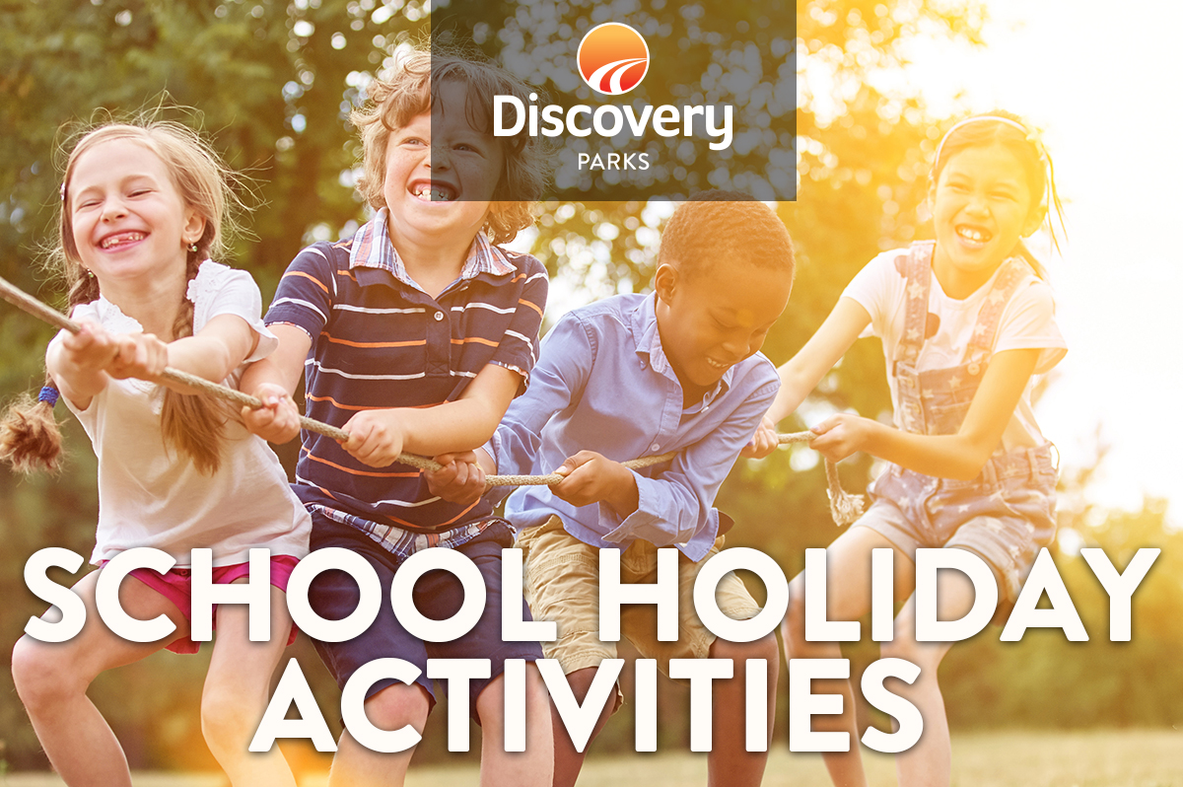
2018 XMAS SCHOOL HOLIDAYS
AT DISCOVERY PARKS – BYRON BAY
Lots and lots of great holiday fun for all the family. From face painting and crazy crafts to movie nights, there are activities planned throughout the school holidays.
18th December 2017 until 28th January 2018
Opening hrs – 10am to 3pm

DATE | TIME | ACTIVITY | VENUE | COST
Sun to Fri | 7pm | Movie | Tennis Court | FREE
Saturdays | 10 am  8pm | String Art  Disco | Kidzklub  BBQ Pool Area &  Tennis Court | FREE  FREE
Sunday | 10am  1pm | Continuous cricket  Crazy Painting | Tennis Court  Kidzklub | FREE  FREE
Mondays | 10am | Novelty Races | Tennis Court | FREE
Mondays | 1pm | Mask making | Kidzklub | FREE
Tuesdays | 10am | Balloon Artist | Kids Club | FREE
Tuesdays | 2pm | Dance and party Games | Kids Club | FREE
Wednesdays | 10am  2pm | Parachute Games  Drawing Competition and Games | Tennis Court  Kidzklub | FREE  FREE
Thursdays | 10am  2pm | Ball Games/Basketball Shooting Comp.  Drumming Workshop | Tennis Court  Tennis Court | FREE  FREE
Fridays | 10am | Art Workshop | Kids Club | FREE
Fridays | 1pm | Face Painting | Kids Club | FREE

