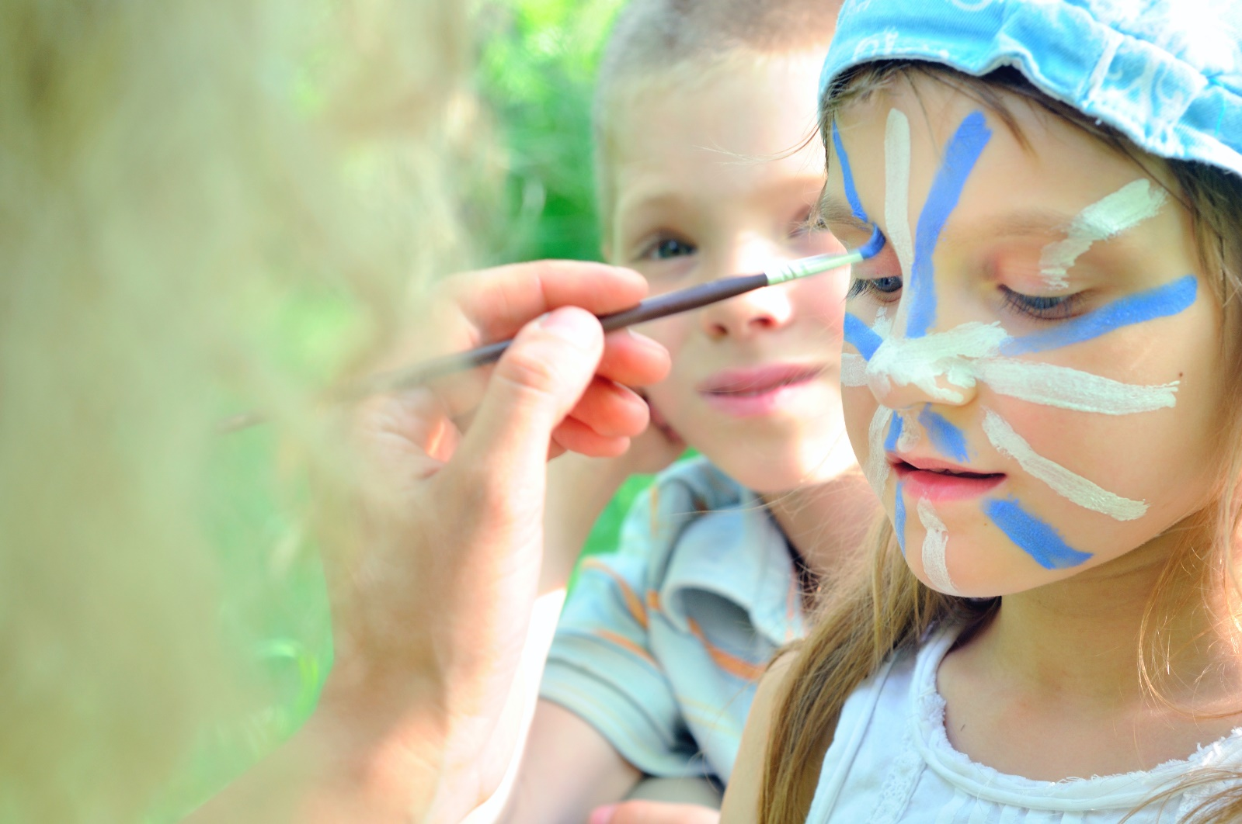
SCHOOL HOLIDAY ACTIVITIES
2017 SRING SCHOOL HOLIDAYS
AT DISCOVERY PARKS – Hervey Bay

Lots and lots of great holiday fun for all the family. From face painting and crazy crafts to movie nights, there’s activities planned throughout the school holidays.

DATE | TIME | ACTIVITY | VENUE | COST
Mon 18th Sept | 10-11am | Bugs Galore | Camp Kitchen | Free
Tues 19th Sept | 10.30-11.30am | Craft Activities | Camp Kitchen | Free
Wed 20th Sept | 9-10am | Pancake Breakfast | Camp Kitchen | Gold Coin Donation to VARIETY
Sat 23rd Sept | 11-12.30 pm | Face Painting | TV Room | Free
Mon 25th Sept | 10.30-11.30am | Bugs Galore | Camp Kitchen | Free
Tues 26th Sept | 10.30-11.30am | Craft Activities | Camp Kitchen | Free
Wed 27th Sept | 9-10am | Pancake Breakfast | Camp Kitchen | Gold Coin Donation to VARIETY
Sat 30th Sept | 10.30-12noon | Face Painting | TV Room | Free
Sat 30th Sept | 12-1pm | Sausage Sizzle  Pre AFL Grand Final | Camp Kitchen | Gold Coin Donation to VARIETY

