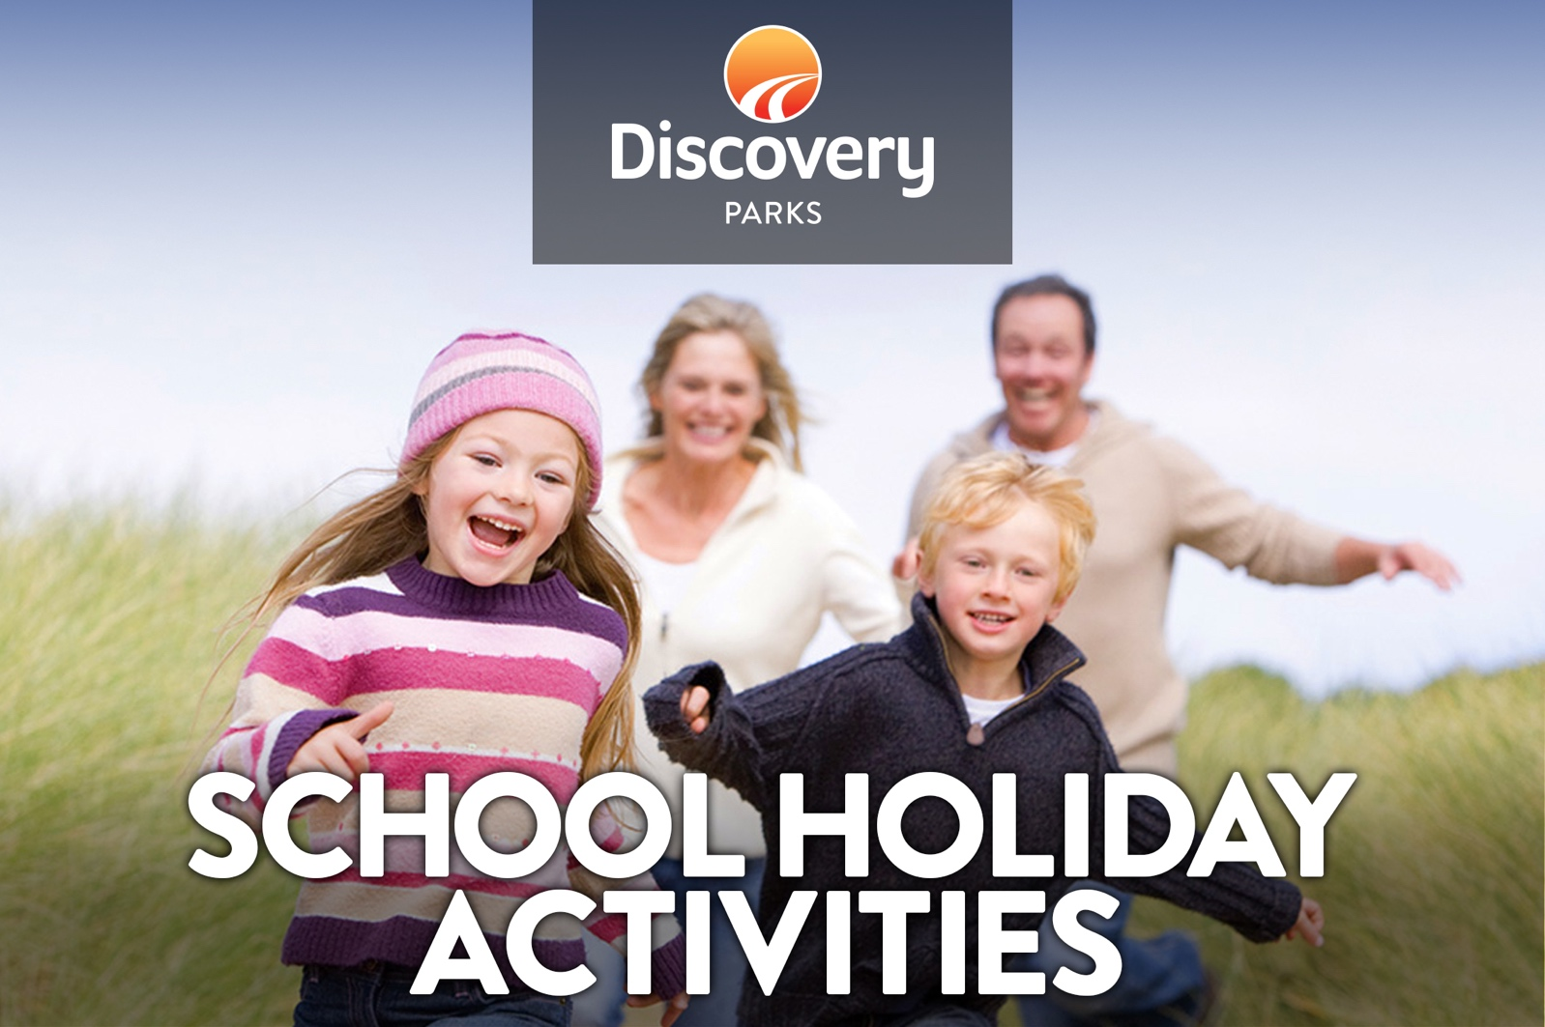
2018 WINTER SCHOOL HOLIDAYS
AT DISCOVERY PARKS – EMERALD BEACH
Lots and lots of great holiday fun for all the family. From face painting and crazy crafts to movie nights, there’s activities planned throughout the school holidays.

DATE | TIME | ACTIVITY | VENUE | COST
29/6/18 | 6pm | Family Movie Night | Movie Room | Free
30/6/18 | 6pm | Family Movie Night | Movie Room | Free
1/7/18 | 6pm | Family Movie Night | Movie Room | Free
2/7/18 | 6pm | Family Movie Night | Movie Room | Free
3/7/18 | 6pm | Family Movie Night | Movie Room | Free
4/7/18 | 6pm | Family Movie Night | Movie Room | Free
5/7/18 | 6pm | Family Movie Night | Movie Room | Free
6/7/18 | 6pm | Family Movie Night | Movie Room | Free
7/7/18 | 6pm | Family Movie Night | Movie Room | Free
8/7/18 | 6pm | Family Movie Night | Movie Room | Free
9/7/18 | 10.30 –12.30 | Make your own placemat | Movie Room | Free
9/7/18 | 6pm | Family Movie Night | Movie Room | Free
10/7/18 | 10.30-12.30 | Chalk Graffiti and games | Movie Room | Free
10/7/18 | 1.30-2.30 | Surf Lessons - Exclusive for park guests  Please book by 10am | Reception | $20 per person
10/7/18 | 6pm | Family Movie Night | Movie Room | Free
11/7/18 | 11am | Pizza making with Matt.  Make your own lunch  Please book by Tuesday lunchtime | Emerald Beach Pizza | $15 per person
11/7/18 | 6pm | Family Movie Night | Movie Room | Free
12/7/18 | 10.30-12.30 | Pet rocks | Movie room | Free
12/7/18 | 1.30-2.30 | Surf Lessons - Exclusive for park guests  Please book by 10am | Reception | $20 per person
12/7/18 | 6pm | Family Movie Night | Movie Room | Free
13/7/18 | 10.30-12.30 | Cookie decorating | Movie Room | Free
13/7/18 | 6pm | Family Movie Night | Movie Room | Free
14/7/18 | 10.30am | Scavenger Hunt | Reception | Free
14/7/18 | 1.30-2.30 | Surf Lessons - Exclusive for park guests  Please book by 10am | Reception | $20 per person
14/7/18 | 6pm | Family Movie Night | Movie Room | Free
15/7/18 | 10.30am | Colouring in | Reception | Free
15/7/18 | 6pm | Family Movie Night | Movie Room | Free
16/7/18 | 10.30-12.30 | Sand art | Movie Room | $2.00
16/7/18 | 6pm | Family Movie Night | Movie Room | Free
17/7/18 | 10.30-12.30 | Family Games |  | Free
17/7/18 | 1.30-2.30 | Surf Lessons - Exclusive for park guests  Please book by 10am | Reception | $20 per person
17/7/18 | 6pm | Family Movie Night | Movie Room | Free
18/7/18 | 11am | Pizza making with Matt.  Make your own lunch  Please book by Tuesday lunchtime | Emerald Beach Pizza | $15 per person
18/7/18 | 6pm | Family Movie Night | Movie Room | Free
19/7/18 | 10.30-12.30 | Make your own place mat | Movie Room | Free
19/7/18 | 1.30-2.30 | Surf Lessons - Exclusive for park guests  Please book by 10am | Reception | $20 per person
19/7/18 | 6pm | Family Movie Night | Movie Room | Free
20/7/18 | 10.30-12.30 | Come catch a fish on our Fishing Simulator | Movie Room | Free
20/7/18 | 6pm | Family Movie Night | Movie Room | Free
21/7/18 | 10.30am | Scavenger Hunt | Reception | Free
21/7/18 | 1.30-2.30 | Surf Lessons - Exclusive for park guests  Please book by 10am | Reception | $20 per person
21/7/18 | 6pm | Family Movie Night | Movie Room | Free
Come along and join in the fun!
Activities and location are subject to change. Activities are run for the enjoyment of the whole family. Family holidays are always a fantastic opportunity for you to have fun with your children. Please understand that our activity program is not a child minding service. Our staff are here to assist and ensure your family has the best time possible.
Look forward to seeing you all there.

